2022 CIF High School Swimming & Diving Standards
*Note: Events are listed in the order they are swam
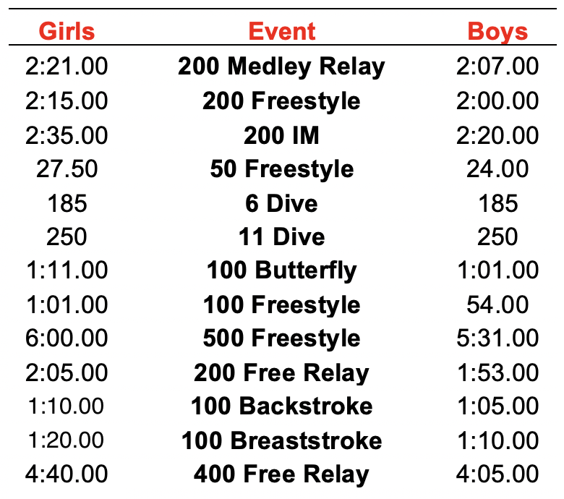

Additional Information about CIF

- Upon qualifying, each athlete must participate in a specified number of meets
- Each team may only register 4 athletes per event from 1 high school
  - After all entries are received, CIF takes the fastest 32 entries
Note: qualifying for CIF does not guarantee an event at CIF.
  - USA swim times are not used. Times must be obtained at a high school meet.
- Only 2 athletes from 1 team can make finals or consults.
- Only 1 relay entry per team

